K_value = [2,3,4,5]

K=2 K=3

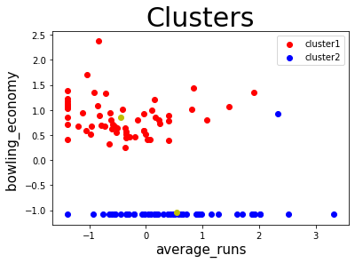 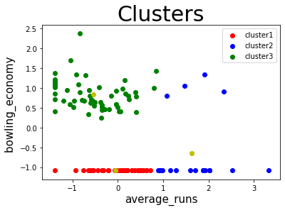

K=4 K=5

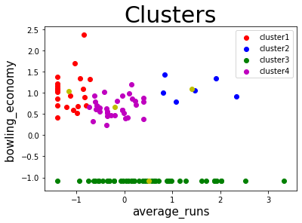 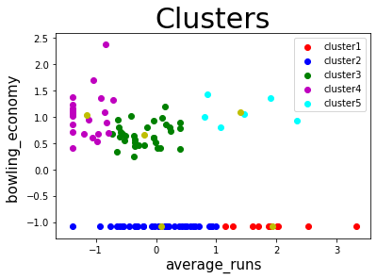

The interpretation of obtained clusters for K=5: -

Cluster1(red): - Players with high average runs (High performance Batsman).

Cluster2(blue): - Players with lower average runs (Low performing Batsman).

Cluster3(green): - Players with medium average runs and good bowling economy(Bowling-All-rounders).

Cluster4(magenta): - Players who are performing good in terms of bowling economy(Bowlers).

Cluster5(cyan): - Players with high average runs and decent bowling economy(Batting-All-rounders)

These clusters can be useful in forming a cricket team with key players.

Best batsman can be taken from cluster_1(preferably form right side of centroids).

Best bowlers can be taken from cluster_4(preferable from lower side of cluster).

Batting All-rounders can be taken from cluster_5(preferably from right side of centroid).

Bowling All-rounders can be taken from cluster_3(preferably from lower side of centroid).

Players from cluster 2 can be avoided as these are not perming well in batting and also cannot bowl.